**PreeWee ORM**

Tutorial page : <http://docs.peewee-orm.com/en/latest/peewee/quickstart.html>

#1 Model Definition

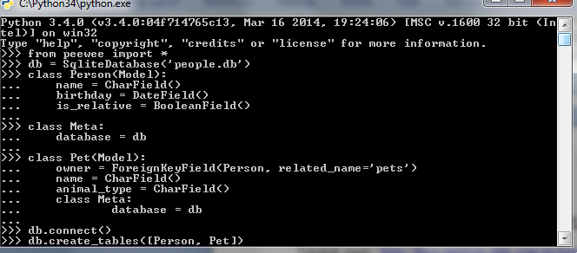

#2 Storing Data

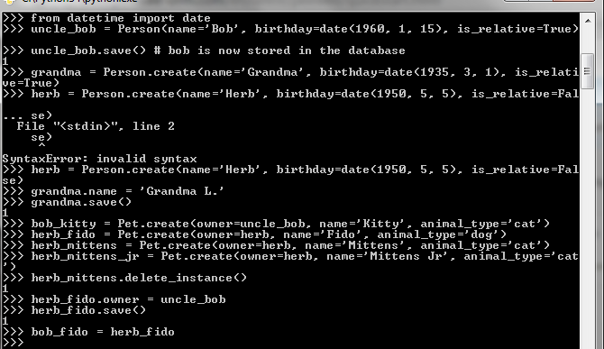

#3 Retrieving Data

